Task 2 - Part 3: Email Summary
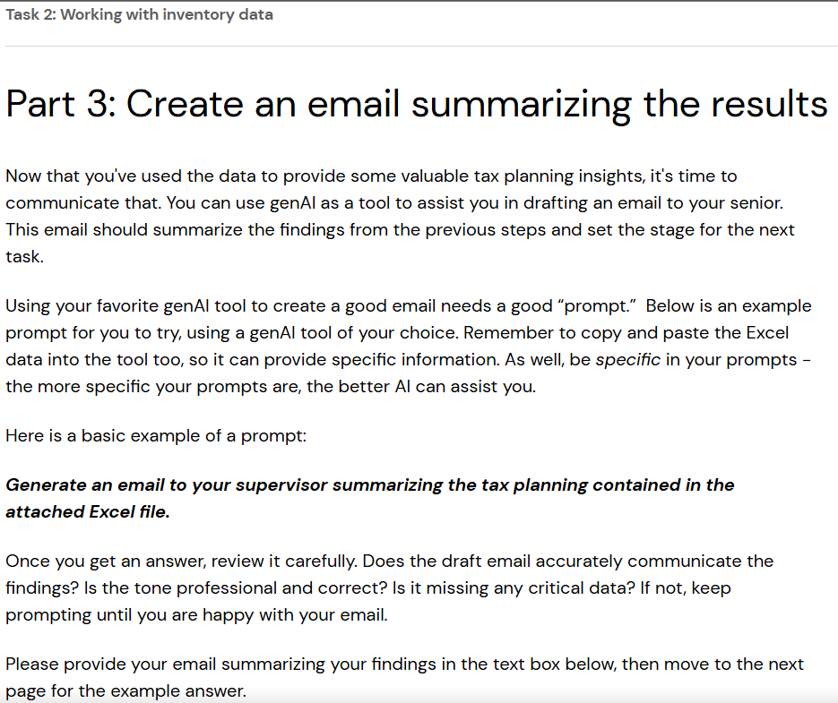

Task 2 Answer - Part 3
Subject: Analysis of Inventory Costing Methods for Bags of Sugar
Dear Supervisor,
I trust this email finds you well. I wanted to provide you with an analysis of our inventory costing methods for bags of sugar, as outlined in the provided data solution.
Below are the summarized findings:
1. Inventory Purchases: The data indicates purchases of bags of sugar from the wholesaler at different costs per bag on various dates throughout the year. These purchases totaled 1000 bags with a cumulative cost of $6,000.
2. Costing Methods:
a) LIFO (Last-In-First-Out): This method assumes that the most recently acquired inventory items are sold first. Under LIFO, the cost of goods sold (COGS) is calculated as the total cost of the 100 bags purchased on 12/6/2022, plus the cost of 100 bags purchased on 12/5/2022, plus the cost of 50 bags purchased on 12/4/2022. This results in a COGS of $1,625.
b) FIFO (First-In-First-Out): FIFO assumes that the oldest inventory items are sold first. Accordingly, the COGS is calculated as the total cost of 100 bags purchased on 9/1/2022, plus the cost of 100 bags purchased on 10/1/2022, plus the cost of 50 bags purchased on 10/1/2022. This results in a COGS of $1,275.
c) Average cost method: This method assumes the total cost of all individual inventory items purchased, divided by the number of items. By dividing the total cost ($6,000) by the total number of bags purchased (1000), you arrive at an average cost of $6.00 per bag. To calculate the inventory valuation, this average cost is multiplied by the number of bags sold (250), resulting in a COGS of $1,500.
3. Income Impact:
Income is lower using the LIFO method compared to FIFO and average cost method. This is because the COGS is higher under LIFO in the case of rising prices, reflecting the higher cost of goods sold from the most recent inventory purchases.
In conclusion, the choice of inventory costing method significantly impacts our financial statements and tax liabilities. The analysis suggests that using LIFO results in lower income compared to FIFO and the average cost method due to the higher cost of goods sold. However, it's essential to consider the broader implications and consult with our accounting team to ensure compliance and optimal financial management.
Please let me know if you require further clarification or analysis on this matter. I'm available to discuss this in more detail at your convenience.
Thank you for your attention to this analysis.
Best regards,
Shaghayegh Haghbin

